Alan Chan 010063326

Dan Lu 011028589

Yanjun Zang 012419394

**Final Project Doc**

For our final project, the codes were developed on a mac with python. We are using python 2.7 for this project and the following packages were used:

* pandas_datareader
* fix_yahoo_finance
* pytz
* requests
* matplotlib.pyplot
* flask (as the server)

File hierarchy:

├── app.py

├── get_data.py

├── static

│ └── styles.css

└── templates

├── chart.html

├── index.html

└── result.html

Flask requires the html template files sit under a directory call templates, and the css being the static file, it is sitting under the directory - static. App.py is the script that will tell the server what to do when a request comes in, and get_data.py is responsible for the stock data fetching.

User will use the index.html page to input data. When the Submit button is hit, app.py will do a validation to make sure all data are inputted correctly. If any error was found, it will display on the result.html page. If no error was found, then it will process to have get_data.py to fetch the necessary data and massage the data to send it to result.html for displaying the results.

On the result.html, it will either have the errors displayed or it will have the result displayed. It will also contain a back link to go back to the index.html page.

If the user wish to see a graph for the past 5 business days history, they would click the Stock Weekly Portfolio History link, which a graph would be rendered for chart.html.

To start the server, just need to run *python app.py*.

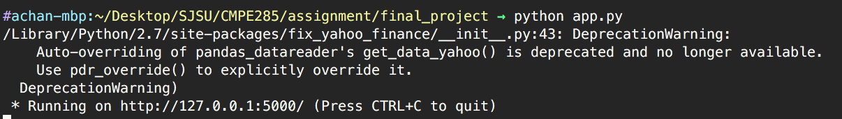

Hit the website with <http://localhost:5000> on the browser.

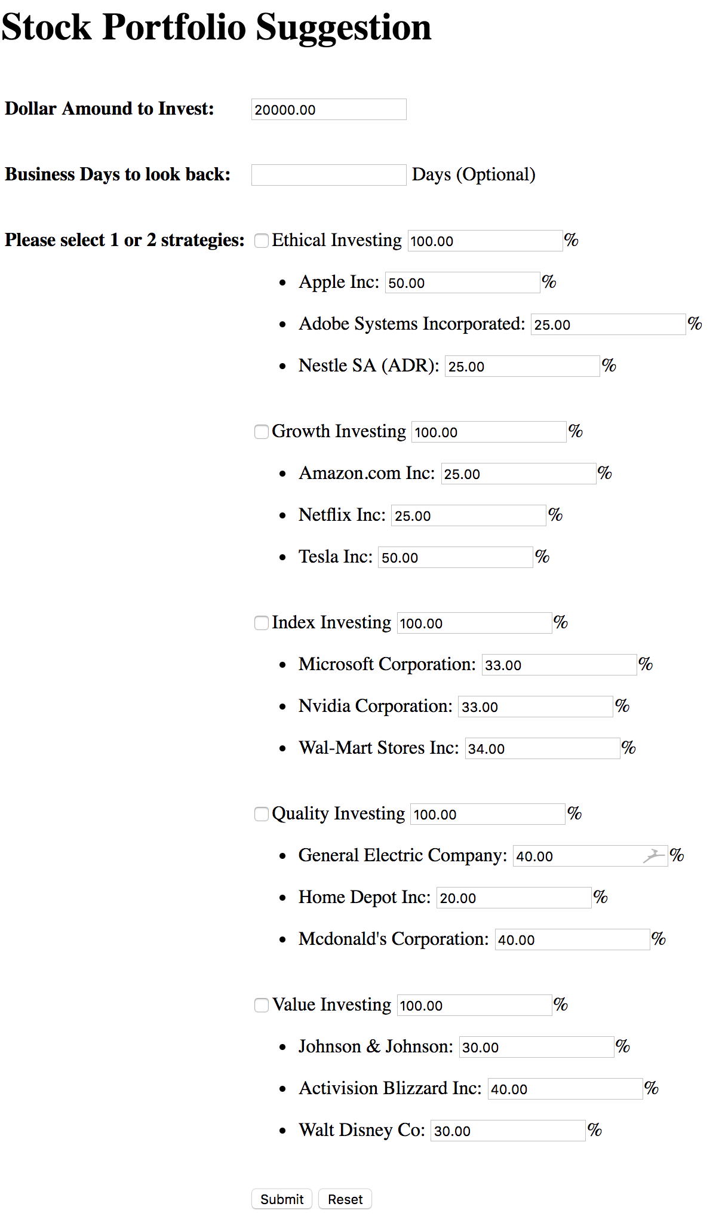

|  |  |  |  |
| --- | --- | --- | --- |
|  | **Description** | **Input** | **Expected** |
| 1 | Input 3000 (or anything lower than 5000) into the amount to invest and hit Submit.  **Expected**: Error pop up. |  |  |
| 2 | Do not select any of the investment strategies and hit Submit.  **Expected**: Error out with ‘Please select 1 or 2 investment strategies‘ |  |  |
| 3 | Select more than 2 investment strategies (Ethical, Growth and Index) and hit Submit.  **Expected**: Error out with ‘Please select 1 or 2 investment strategies‘ |  |  |
| 4 | Select Growth Investment and Index Investment as the two strategies, and leave the distribution as 100 for both.  **Expected**: Error out with ‘Please make sure all selected investment strategies add up to 100%‘ |  |  |
| 5 | Select Value Investment and put 70 on the distribution, and hit Submit.  **Expected**: Error out with ‘Please make sure all selected investment strategies add up to 100%‘ |  |  |
| 6 | Select Value Investment and hit Submit. Once the result page is displayed, hit the back link.  **Expected**: Back to the front page. |  |  |
| 7 | Select Value Investment, put 70 on the distribution. Hit Submit. Once the result page is displayed, hit the back link.  **Expected**: Back to the front page. |  |  |
| 8 | Select Ethical Investment, leave 100 on the distribution. Leave the distribution on the stocks as default and hit Submit. Then hit the Stock Portfolio Weekly History link.  **Expected**: Display a 5 days look back graph. |  |  |
| 9 | Put 50000 as the investment. Select Index Investment and Quality Investment. Put 50 as distribution for both. Hit Submit.  **Expected**: Current price, current value, 5 business days prior purchased and 10 business days prior purchased for 6 stocks. |  |  |
| 10 | As we have been leaving the Business Look Back section blank, now look back 900 days. Put 900 into the textbox. Select Ethical Investment and hit Submit.  **Expected**: Current price, current value, 5 business days prior purchased, 10 business days prior purchased and 900 business days prior purchased for 3 stocks. |  |  |